ROC Swimmer wins gold at the Eastern Canada Swimming Championship!
On February 19th, 2015 at the Speedo Eastern Canada Swimming Championship held at the University Laval in Quebec, magic happened for one young Clarington Swimmer. Aleena Luetchford (14) of the Clarington Swim Club (ROC) was ranked 13th overall going into the 50m butterfly event. By the end of the day she was on the top of the podium with a gold medal around her neck, and her time ranked her #1 in Canada in her age group. But not only was she the Eastern Canada Champion, she also swam fast enough to qualify for the Pan American Games Trials on April 1 -4th at the new Pan Am pool in Scarborough, and has a shot at a spot on the Pan American Team.

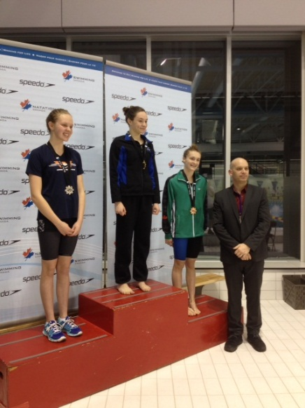
Aleena also completed in the 100 Butterfly event with a seed time of 1:06.12s. Aleena brought the same intensity to this swim and made the finals with a preliminary a Personal Best time of 1:04.75s. In the finals, Aleena got the Bronze medal with another Personal Best time of 1:03.64s.
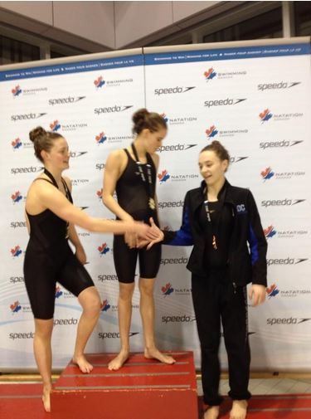

Aleena started her swimming career at the age of 9. Her mom and dad (Marnie and Rob Luetchford) knew Aleena was a fish when they removed her lifejacket at their home pool and Aleena proceeded to swim from one side to the other completely underwater. That’s when they decided to enroll Aleena in the Clarington Swim Club, first as a Novice Swimmer, then a year later, Aleena began to compete. It was then that she began to set her goals on always achieving personal best performances and leaving it all in the pool when competing at meets.

Her dedication to swimming and the training required is evident by the attitude she brings to the sport. Aleena trains extremely hard 6 days a week and on the 7th day plays Waterpolo with the team. She attends Bowmanville High School in grade 9 and maintains a good grade average. This leaves little time for socializing but Aleena has a great group of friends within and outside the club who understand that this level of dedication comes with a few sacrifices.

And with that level of dedication and focus, Aleena’s goal was to make it to Olympic trials, who knew it would be well within her grasp!

The Clarington Swim Club (ROC) has not had a swimmer qualify at this level in about 15-17 years however, the club has seen an increase in the number of swimmers qualifying for Championship meets, Provincial meets and National meets in recent years. This speaks volumes about the caliber of young swimmers who are dedicated in training both in and out of the pool as well as a disciplined approach to coaching, demanding that swimmers give their best and are consistent with the team’s trade mark of “NEVER, NEVER, NEVER GIVE UP”.

